LAB - 8

|  |  |
| --- | --- |
| Name | Keval D Gandevia |
| Roll Number | CE046 |
| ID | 19CEUEG017 |
| Subject | Image Processing |

**Aim:** Introduction to Morphological Image Processing

**Q. 1: Create input image of size 9x9 as shown below. Perform ‘Erosion’, ‘Dilation’, ‘Opening’ and ‘Closing’ operations using ‘Disk’ structuring element of size ‘1’.**

* **Code:**

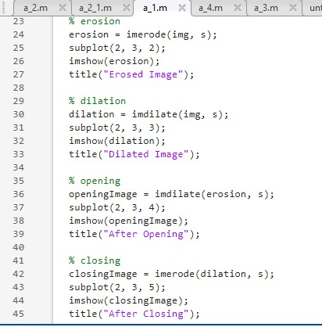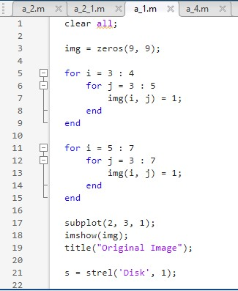

* **Output:**

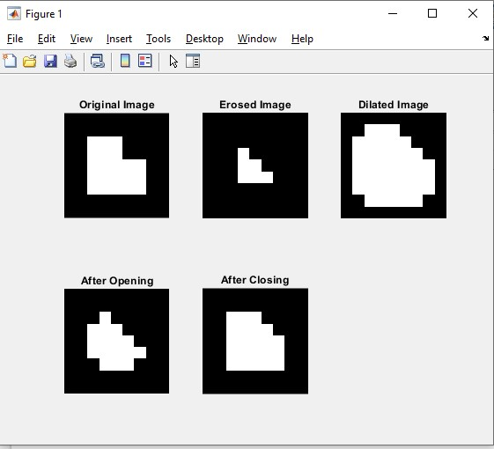

* **By using manual erosion and dilation function:**
* **Code of Erosion function: (Note: Remains same for all manual programs)**

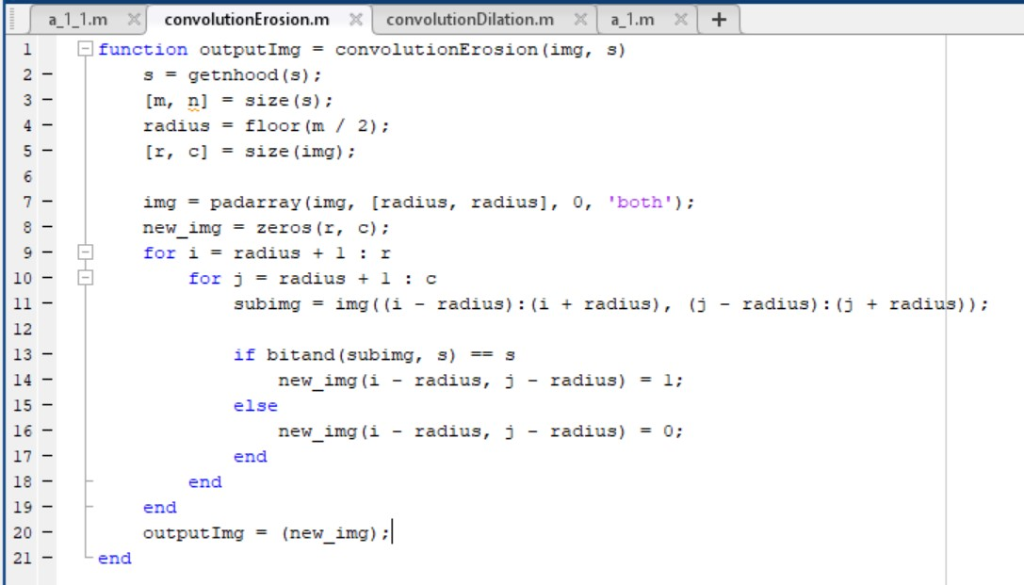

* **Code of Dilation function: (Note: Remains same for all manual programs)**

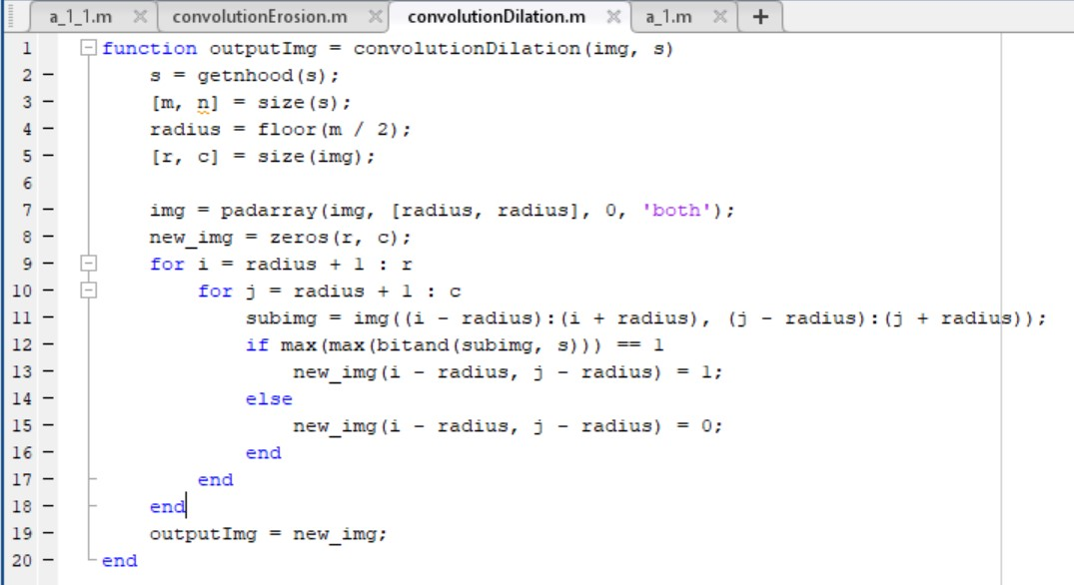

* 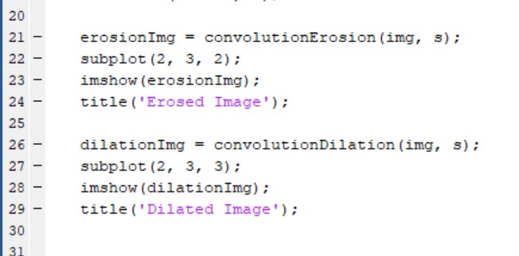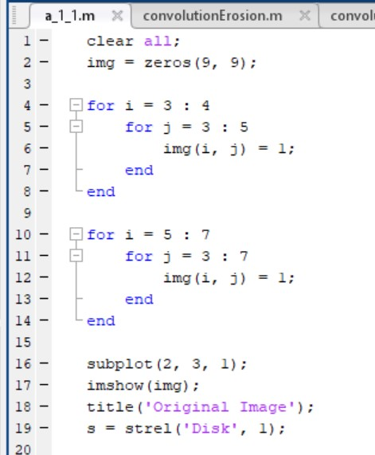**Code:**
* **Output:**

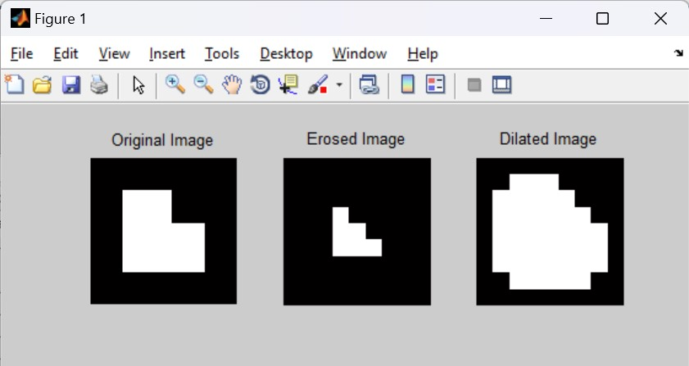

**Q. 2: Download ‘banana’ image. Convert it into black and white image as shown below. Perform ‘Erosion’ and ‘Dilation’ operation with ‘Disk’ and ‘Square’ structuring elements.**

* **By using in-built function:**
* **Code with ‘disk’ as structuring element:**

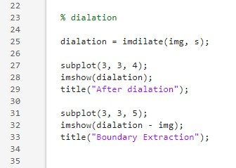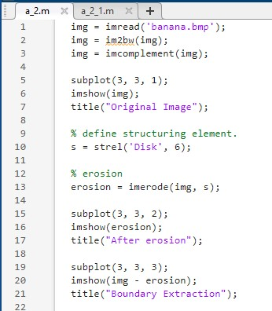

* Output:

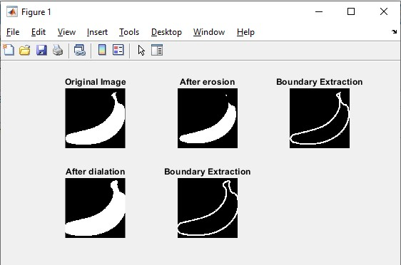

* **Code with ‘square’ as a structuring element:**

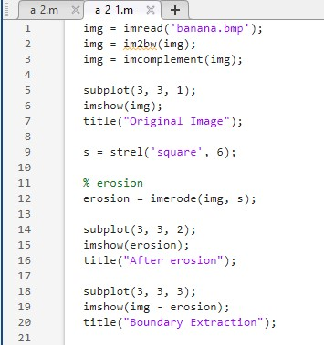

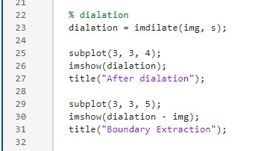

* **Output:**

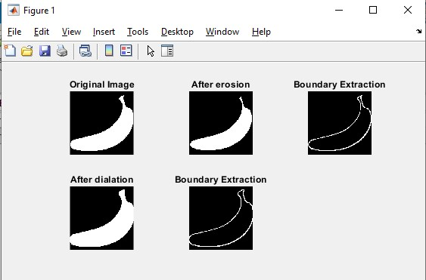

* **By using manual function:**
* **Code:**

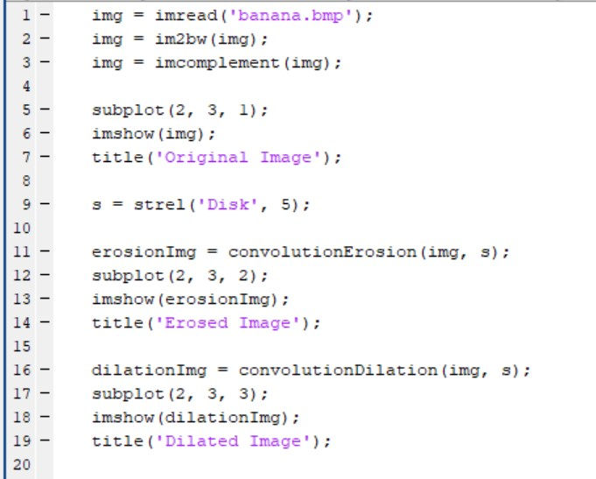

* **Output:**

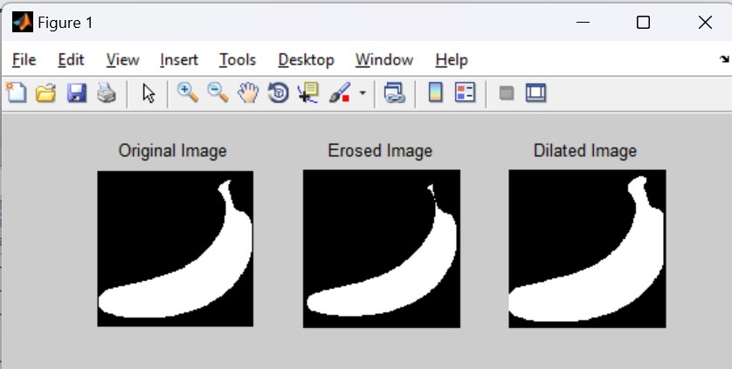

**Q. 3: Read in the image ‘blobs.png’. This image should already be available with MATLAB as it comes with the Image Processing Toolbox. Perform ‘Opening’ and ‘Closing’ operations on the given image with ‘Disk’ structuring element of size ‘5’.**

* **By using in-built function:**
* **Code:**

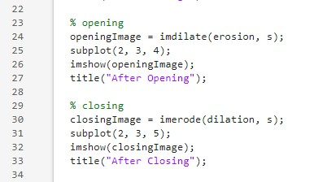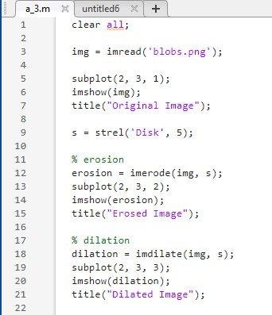

* **Output:**

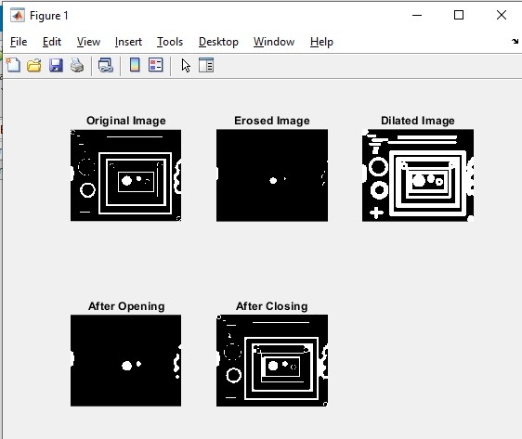

* **By using manual function:**
* **Code:**

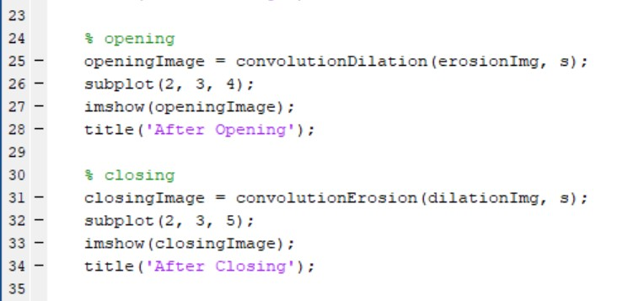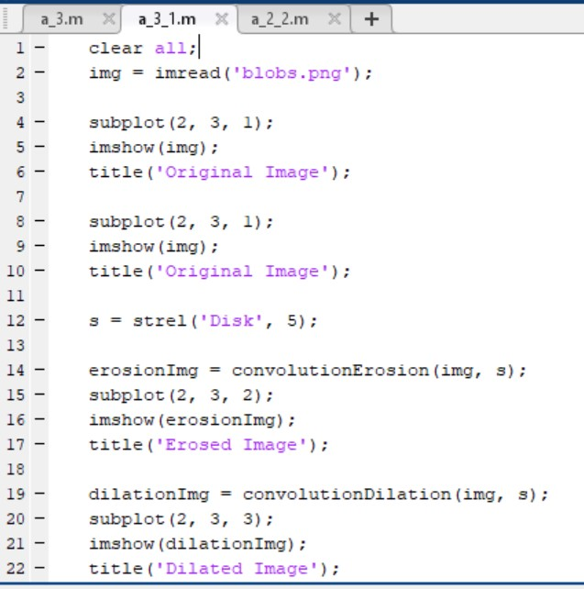

* **Output:**

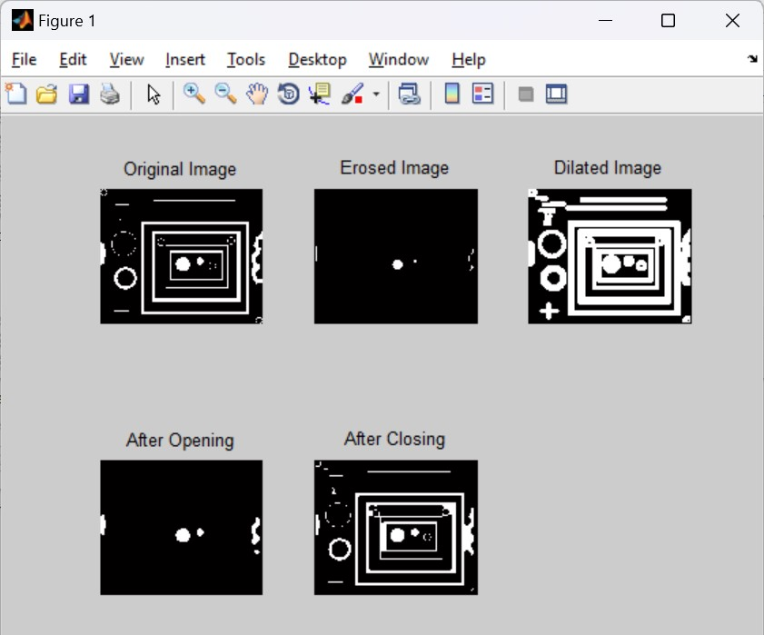

**Q. 4: Perform ‘Boundary Extraction’ Operation on ‘Banana’ and ‘Shapes’ images.**

* **By using in-built function:**
* **Code:**

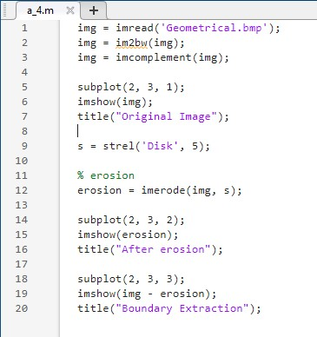

* **Output:**

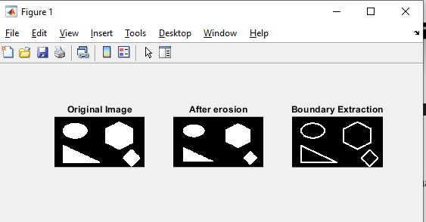

* **By using manual function:**
* 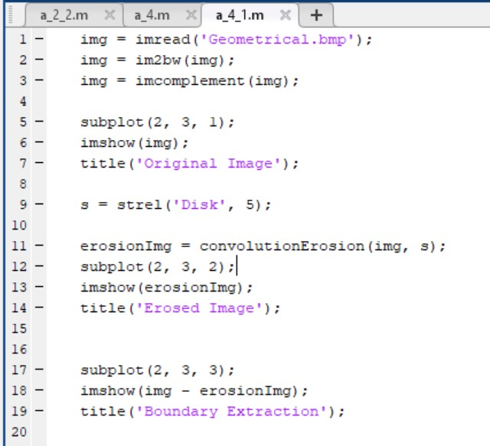**Code:**
* **Output:**

